Department of Computer Engineering
Practical - 5

Practical Title: Registration Form with Frontend Validation and User-Friendly Error Handling
Problem Definition: Create a student registration form using HTML5 input types and JavaScript validation. The form should validate name, email, mobile number, password, confirm password, course, year, gender, and terms acceptance using Regular Expressions where appropriate. Validation errors should be displayed near the relevant fields in a clear and user-friendly manner. The form should also include a password strength meter and accessible labels so that it can be used effectively with keyboards and screen readers.
Theory :
1. Are correct input types and attributes used?
Yes. Appropriate HTML5 input types and attributes such as text, email, tel, password, radio buttons, select, required, minlength, maxlength, and pattern can be used to collect and validate student registration data correctly.
2. Are validation errors displayed near the relevant fields?
Yes. Each field should have a dedicated error message area near it. When invalid data is entered, JavaScript displays a clear message beside the relevant field instead of showing only a general error at the top of the form. This helps the user identify and correct the problem quickly.
3. Is password strength checked?
Yes. Password strength can be checked using JavaScript and Regular Expressions. The validation can verify requirements such as minimum length, uppercase letters, lowercase letters, numbers, and special characters. A password strength meter can indicate whether the password is weak, medium, or strong.
4. Is the form accessible using keyboard and screen-reader-friendly labels?
Yes. The form should use proper label elements associated with their input fields, logical tab order, meaningful error messages, and accessible attributes where required. Users should be able to move through the complete form using the keyboard, while screen readers should be able to identify the fields and their associated instructions or errors.

Implementation/ Output/Result
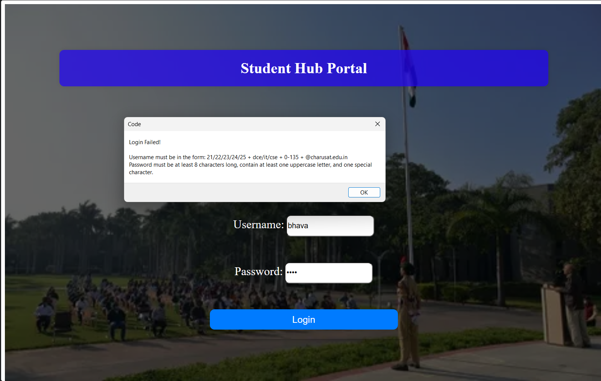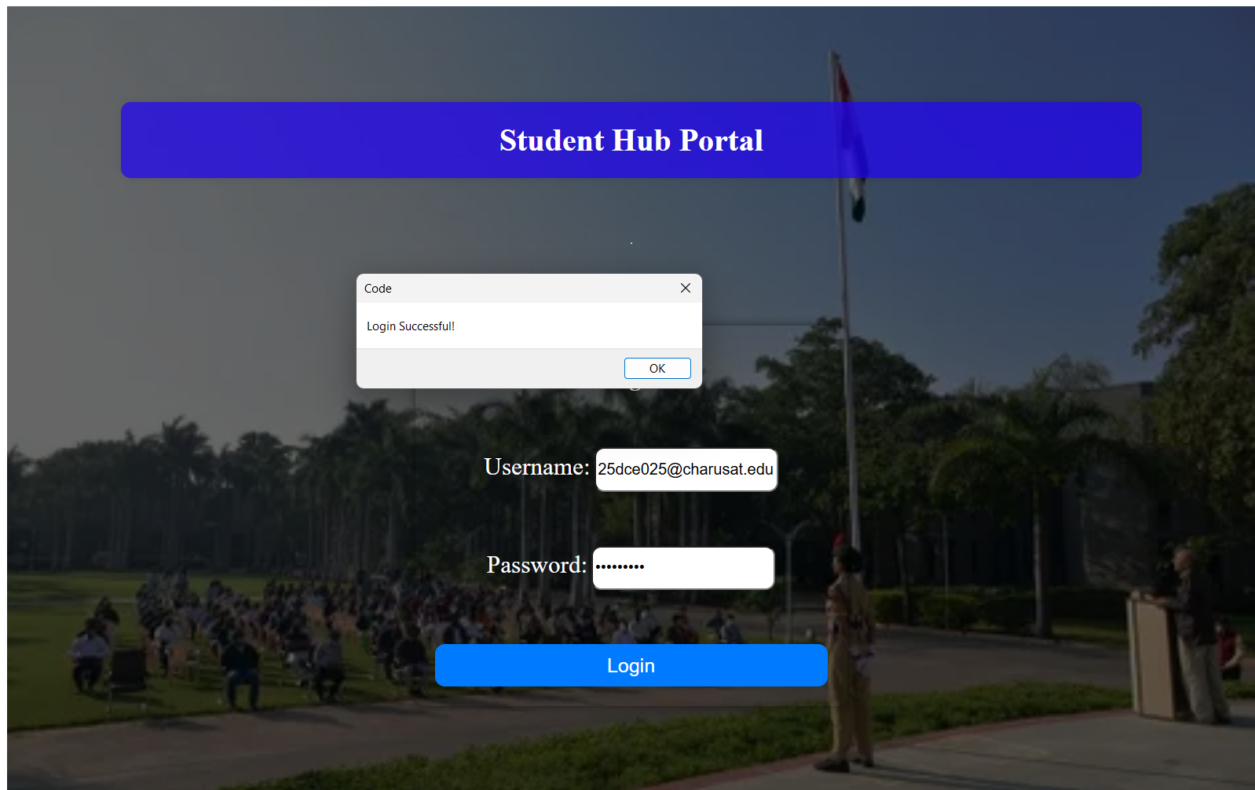

GitHub Repository Link:
https://github.com/25dce025-debug/WEB-DEVELOPMENT-WDF-
Learning Outcomes:
- Design student registration forms using HTML5 form elements.
- Use JavaScript for client-side form validation.
- Apply Regular Expressions to validate user input.
- Implement a password strength meter.
- Display clear and user-friendly validation error messages.
- Create accessible forms with keyboard and screen-reader-friendly labels.
- Test forms using valid and invalid input cases.

